Client Request and Server Response

🔹 What is a Client Request?
# Source: AI Source: Provided by: [Data Path: Persons Table -> ID Column: 1, Name_En Column: Motasem Essam] -> From: [ChatGPT] on [1/16/2026]
A client request is a message or signal sent by the client to the server, asking for a specific resource or service.
- It usually includes:
  - The type of request (e.g., GET, POST in HTTP)
  - The resource being requested (like a web page, image, or data)
  - Any parameters or data needed by the server to process the request (like a username, search term, etc.)
📘 Example:
- A web browser (client) sends a GET request to a server to load www.example.com/home.
- A mobile app might send a POST request with login credentials to authenticate a user.

🔹 What is a Server Response?
# Source: AI Source: Provided by: [Data Path: Persons Table -> ID Column: 1, Name_En Column: Motasem Essam] -> From: [ChatGPT] on [1/16/2026]
A server response is the message or data that the server sends back to the client after processing the request.
- It usually includes:
  - A status code (e.g., 200 OK, 404 Not Found, 500 Internal Server Error)
  - The requested data or an error message
  - Optional headers or metadata about the response
📘 Example:
- The server responds with an HTML page for the home screen.
- The server returns a JSON object with user profile details.

🔹 Relationship Between a Request and a REST API

🔹 What Is the Relationship Between a Request and a REST API?
# Source: AI Source: Provided by: [Data Path: Persons Table -> ID Column: 1, Name_En Column: Motasem Essam] -> From: [ChatGPT] on [1/16/2026]
A REST API (Representational State Transfer API) is a way for clients and servers to communicate using HTTP requests and responses.
So, the request is the action the client performs, and the REST API defines the rules and structure for how that action is carried out.

✅ Relationship Explained:
# Source: AI Source: Provided by: [Data Path: Persons Table -> ID Column: 1, Name_En Column: Motasem Essam] -> From: [ChatGPT] on [1/16/2026]
Concept | Explanation
Request | The message the client sends to ask for data or perform an action (e.g., create, read, update, delete).
REST API | A set of rules (architecture) that tells how requests should be structured and how the server should respond.
The request is how you interact with a REST API.

✅ Example of a REST API Request
# Source: AI Source: Provided by: [Data Path: Persons Table -> ID Column: 1, Name_En Column: Motasem Essam] -> From: [ChatGPT] on [1/16/2026]
Let’s say there's a REST API for users:
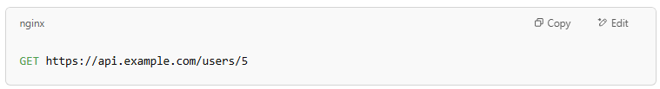
GET https://api.example.com/users/5
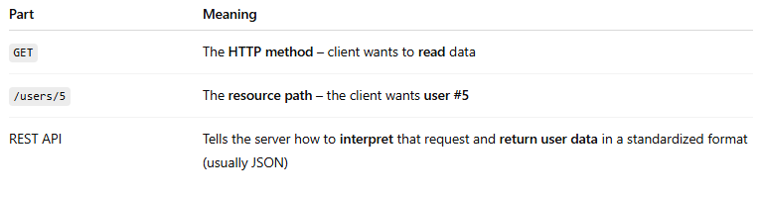

Part | Meaning
GET | The HTTP method – client wants to read data
/users/5 | The resource path – the client wants user #5
REST API | Tells the server how to interpret that request and return user data in a standardized format (usually JSON)

✅ Common HTTP Methods Used in REST APIs (Mapped to Actions)
# Source: AI Source: Provided by: [Data Path: Persons Table -> ID Column: 1, Name_En Column: Motasem Essam] -> From: [ChatGPT] on [1/16/2026]
HTTP Method | Action | REST Meaning
GET | Read data | Retrieve a resource
POST | Create | Add a new resource
PUT | Update | Update an existing resource
DELETE | Remove | Delete a resource

🧠 Key Point:
# Source: AI Source: Provided by: [Data Path: Persons Table -> ID Column: 1, Name_En Column: Motasem Essam] -> From: [ChatGPT] on [1/16/2026]
A request is how a client uses a REST API to access or change resources on the server.

✅ Summary:
# Source: AI Source: Provided by: [Data Path: Persons Table -> ID Column: 1, Name_En Column: Motasem Essam] -> From: [ChatGPT] on [1/16/2026]
- A client request is the action.
- A REST API is the system that defines how that action should happen using HTTP.
- REST APIs use standard request types (GET, POST, etc.) and URLs to interact with resources.
Let me know if you want a working example using code like JavaScript or Python!

🔹 Relationship Between a response and a REST API

🔹 What Is the Relationship Between a Response and a REST API?
# Source: AI Source: Provided by: [Data Path: Persons Table -> ID Column: 1, Name_En Column: Motasem Essam] -> From: [ChatGPT] on [1/16/2026]
A REST API (Representational State Transfer API) defines how a server should respond to client requests in a structured, predictable way. The response is the server’s answer to a client’s request made through the REST API.

✅ Relationship Explained:
# Source: AI Source: Provided by: [Data Path: Persons Table -> ID Column: 1, Name_En Column: Motasem Essam] -> From: [ChatGPT] on [1/16/2026]
Concept | Explanation
Response | The message the server sends back after processing a client’s request. It contains a status code, headers, and usually a body with data or confirmation.
REST API | The set of rules that define how the server formats and sends that response to make communication consistent and meaningful.
The response is how the REST API communicates results of requests back to the client.

✅ What a REST API Response Typically Includes:
# Source: AI Source: Provided by: [Data Path: Persons Table -> ID Column: 1, Name_En Column: Motasem Essam] -> From: [ChatGPT] on [1/16/2026]
Component | Purpose | Example
Status Code | Indicates success or failure | 200 OK, 404 Not Found
Headers | Metadata about the response | Content-Type: application/json
Body | Data or message returned | JSON object representing a user, error message, or confirmation

✅ Example of a REST API Response:
# Source: AI Source: Provided by: [Data Path: Persons Table -> ID Column: 1, Name_En Column: Motasem Essam] -> From: [ChatGPT] on [1/16/2026]
If a client sends a request to get user data:
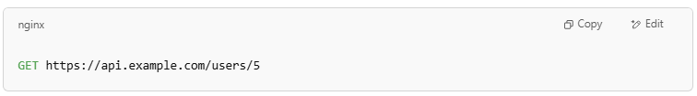
GET https://api.example.com/users/5

The server might respond with:
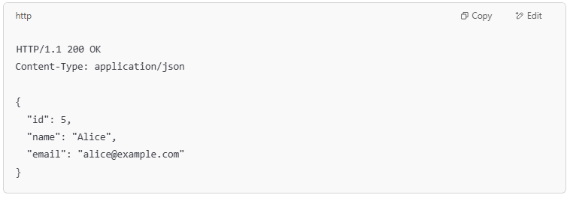
HTTP/1.1 200 OK
Content-Type: application/json

{
"id": 5,
"name": "Alice",
"email": "alice@example.com"
}

🧠 Key Point:
# Source: AI Source: Provided by: [Data Path: Persons Table -> ID Column: 1, Name_En Column: Motasem Essam] -> From: [ChatGPT] on [1/16/2026]
A response is the REST API’s way of delivering the result of the client’s request, following standardized formats so clients can easily understand and process the data or status.

✅ Summary:
# Source: AI Source: Provided by: [Data Path: Persons Table -> ID Column: 1, Name_En Column: Motasem Essam] -> From: [ChatGPT] on [1/16/2026]
- The response is the server’s reply in the REST API communication.
- REST API defines the format and meaning of the response (status codes, JSON data, etc.).
- Together, requests and responses form the full interaction in a RESTful system.
Want me to show you how to handle REST API responses in code?

🔹 Technologies that make client request and server response

🔹 What Are the Technologies That Make Client Requests and Server Responses Possible?
# Source: AI Source: Provided by: [Data Path: Persons Table -> ID Column: 1, Name_En Column: Motasem Essam] -> From: [ChatGPT] on [1/16/2026]
To enable communication between clients (like browsers or mobile apps) and servers (web servers, APIs), various technologies, protocols, and tools work together.

✅ 1. Protocols
# Source: AI Source: Provided by: [Data Path: Persons Table -> ID Column: 1, Name_En Column: Motasem Essam] -> From: [ChatGPT] on [1/16/2026]
Technology | Role | Description
HTTP / HTTPS | 📡 Core communication | Protocol for sending client requests and receiving server responses over the web. HTTPS is the secure, encrypted version.
TCP/IP | 🧱 Network transport | Underlying protocol suite that transfers data between client and server reliably.
DNS | 📘 Domain name lookup | Translates domain names (e.g., google.com) into IP addresses to find the correct server.

✅ 2. Client-Side Technologies (Used to make requests)
# Source: AI Source: Provided by: [Data Path: Persons Table -> ID Column: 1, Name_En Column: Motasem Essam] -> From: [ChatGPT] on [1/16/2026]
Technology | Role | Description
Web Browsers | Interface | Software like Chrome, Firefox, or Safari that sends HTTP requests and shows server responses (web pages).
JavaScript (AJAX, Fetch API) | Code-based requests | Used in web pages to make background HTTP requests (e.g., fetch() or XMLHttpRequest).
Mobile Apps | App-based clients | Use networking libraries to send requests (e.g., Retrofit in Android, Alamofire in iOS).
cURL | Command-line tool | Used to manually send HTTP requests from the terminal.
Postman / Insomnia | API testing tools | Used by developers to send and inspect HTTP requests and responses easily.

✅ 3. Server-Side Technologies (Used to process and respond to requests)
# Source: AI Source: Provided by: [Data Path: Persons Table -> ID Column: 1, Name_En Column: Motasem Essam] -> From: [ChatGPT] on [1/16/2026]
Technology | Role | Description
Web Servers | Handles HTTP | Examples: Apache, Nginx – receive and respond to HTTP requests.
Server-Side Languages | Backend logic | Examples: Node.js, Python (Flask/Django), PHP, Java (Spring), Ruby on Rails.
Databases | Store data | Examples: MySQL, MongoDB, PostgreSQL – servers often fetch data from databases to include in responses.
RESTful APIs / GraphQL | Structured data exchange | Frameworks that define how data is requested and sent between client and server.

✅ 4. Middle Layers (Optional)
# Source: AI Source: Provided by: [Data Path: Persons Table -> ID Column: 1, Name_En Column: Motasem Essam] -> From: [ChatGPT] on [1/16/2026]
Technology | Role | Description
Reverse Proxies | Forwarding | Examples: Nginx, HAProxy – route client requests to the right server or app.
API Gateways | Manage APIs | Handle authentication, rate-limiting, logging, and more.
CDNs | Content delivery | Distribute responses (like images, JS files) from servers closest to the client.

💡 Example Workflow:
# Source: AI Source: Provided by: [Data Path: Persons Table -> ID Column: 1, Name_En Column: Motasem Essam] -> From: [ChatGPT] on [1/16/2026]
- A user clicks a link in a browser.
- The browser sends an HTTP GET request using TCP/IP to the server.
- The server (built in Node.js or Python, for example) processes it.
- If needed, the server pulls data from a database.
- The server sends back an HTTP response with a status code and content.
- The browser receives the response and displays the result to the user.

💡 Real-World Analogy:
# Source: AI Source: Provided by: [Data Path: Persons Table -> ID Column: 1, Name_En Column: Motasem Essam] -> From: [ChatGPT] on [1/16/2026]
- Client Request: You order food at a restaurant (asking for a specific dish).
- Server Response: The kitchen prepares and brings your dish to your table.

